CS590BD Big Data Analytics and Apps

**LAB - 6**

**Report on the app developed for Display Chart Based on the Gestures of day Using Sensor**

**By,**

**Ponnam Balakrishna**

**Kommineni Siva Krishna**

**Boyanapalli Swathi**

**Pathuri Savya Sri**

**Running Tetris Game:**

We have chosen a game called **Tetris** played by most of them at their childhood in videogames.

This game sent the different shapes coming down. Those objects can be **Rotate** to change their shape and can be moved towards **Left** or towards **Right.** On making a Row without any space the row will be deleted. Thus if the rows are made with spaces left then the objects get increasing and will touch the high where the game will be finished.

Now we have done the game running by using the sensor tag. We have made a total of five gestures **Right, Left, Rotate, Punch and Down**. The Right is to move the object towards Right, Left is to move the object towards Left, Rotate is to Change the shape of the object, down is to bring the object down in fast and punch as to play the game.

On running the game with sensor devices we get the Play and chart button.

The below screen shot shows the beginning of the game with the play and Chart button:

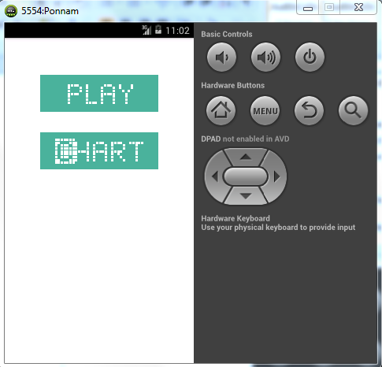

On Punch the play button gets activated and the game will be running by generating the objects. Those objects can be moved towards Right, Left and can also rotate the object using the sensor.

The below screen shows the objects falling down and which are moved towards left, right and rotated by using the Sensor device:

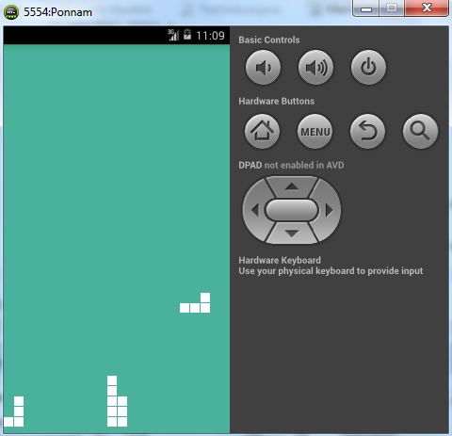

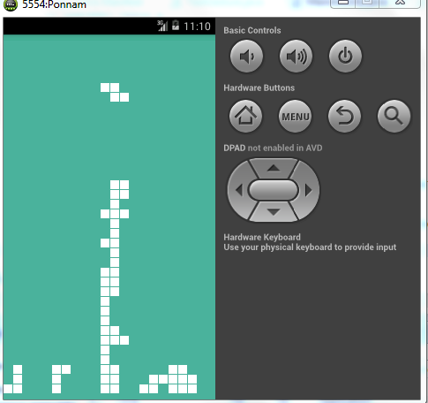

**Generating Charts for the Gestures:**

The game is played by using the sensor tag where generating five different Gestures.

We have collected a report of how many times the particular gesture is being performed. We collected five gestures Rotate, Right, Left, down and Punch. We took the count of each gesture performed while playing the game. The individual Gesture count is sent to the database with the date.

Thus we generate a pie chart for all gestures based on the date by retrieving those data from the database.

The below screen shows the main screen with play and chart button:



We have a chart button, on pressing the chart button we get the drop down which has all the dates in which we played the game. On selecting the date and pressing the submit button we get the pie chart with gestures we have used.

The below screen shows the selection of Date with drop down and submit button:

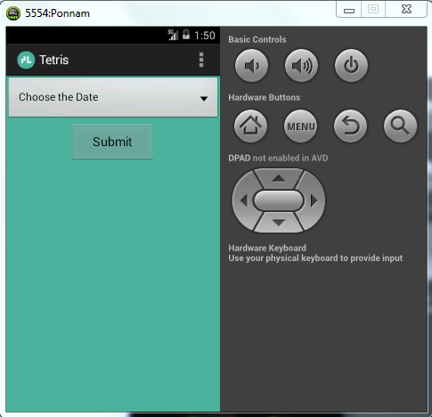

The below screen shot shows the selection of date from the dropdown:

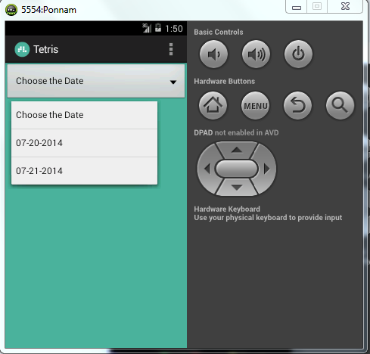

On selecting the date and pressing the Submit button we get the Pie Chart with the gestures we have used.

Here the Date is from the database which selects all the dates with the gesture. It removes the Duplicates and shows the available dates in the drop down box.

On selecting the particular day it fetches all the gestures used and its count and draws the pie chart based on the count of the particular gesture.

The below screen shows the Pie Chart of the Gestures we have used:

